**Title:**

Dominance of IL-5 and CCL17 in Nasal Cytokine Profiles of Children with Type 2 Inflammation

**Authors:**

Tamo Sultan, MD1,2,3, Nicklas Brustad, MD, PhD1, Julie Nyholm Kyvsgaard, MD, PhD1, Frederikke Skov, MD1,2,3, Laura Marie Hesselberg, MD1 Jonathan Thorsen, MD, PhD1+3, Nilo Vahman, MD, PhD1, Ann-Marie Malby Schoos, MD, PhD, DMSc1,2,3, Jakob Stokholm, MD, PhD1,3, Susanne Brix, MSc, PhD4, Klaus Bønnelykke, MD, PhD1,3, Bo Chawes, MD, PhD, DMSc1,3.

**Affiliation:**

1) COPSAC, Copenhagen Prospective Studies on Asthma in Childhood, Copenhagen University Hospital - Herlev and Gentofte, Copenhagen, Denmark

2) Department of Pediatrics, Slagelse Hospital, Slagelse, Denmark.

3) Department of Clinical Medicine, Faculty of Health and Medical Sciences, University of Copenhagen, Copenhagen, Denmark.

4) Department of Biotechnology and Biomedicine, Technical University of Denmark, Kgs. Lyngby, Denmark.

**Source of Funding:**

This study was funded by Børnelungefonden, Sanofi A/S and Naestved, Slagelse and Ringsted Hospitals (NSR) Research Fund.

All funding received by COPSAC is listed on www.copsac.com. The Lundbeck Foundation (Grant no R16-A1694); The Ministry of Health (Grant no 903516); Danish Council for Strategic Research (Grant no 0603-00280B) and The Capital Region Research Foundation have provided core support to the COPSAC research center.

**ABSTRACT (250 words)**

**Background**: Type 2 inflammation, driven by Type 2 immune and epithelial cells and associated cytokines, has been linked with asthma, allergic rhinoconjunctivitis (ARC), and atopic dermatitis (AD). Early detection and precise immune-phenotyping of type 2 related diseases in childhood is crucial for effective targeted therapies.

**Objective**: To evaluate the usefulness of a non-invasive method to measure nasal cytokine profiles for immune-phenotyping type 2 inflammation in 6-year-old children.

**Methods**: Nasal lining fluid was analyzed for levels of 24 cytokines in 612 children at 6 years from the Danish COPSAC2010 mother-child cohort with prospective diagnoses of atopic diseases (asthma, ARC, and AD) and assessments of type 2 biomarkers including blood eosinophils, FeNO, total-IgE, specific-IgE and skin prick test for aeroallergens. Associations between nasal cytokine levels, atopic diseases, and biomarkers were analyzed using Spearman’s correlation and linear regression models, adjusted for false discovery rate (FDR).

**Results:** FDR-adjusted analyses showed that children with T2-high asthma at age 6 years had increased nasal IL-5 levels and children with ARC had increased nasal IL-5, CCL17, CCL13, and CCL26 levels, whereas there were no associations between nasal cytokine levels and AD. Further, positive associations were observed between nasal IL-5 levels and all T2 biomarkers. CCL17 was associated with all T2 biomarkers except specific-IgE, while CCL26 was associated with a positive skin prick test.

**Conclusion**: This study highlights the usefulness of non-invasive nasal lining fluid sampling for detecting type 2 inflammation in 6-year-old children. Particularly, nasal IL-5 and CCL17 emerged as consistent biomarkers for type 2 allergic diseases.

**Keywords**: Type 2 cytokines, allergic disease, nasal sampling, pediatric asthma, biomarkers

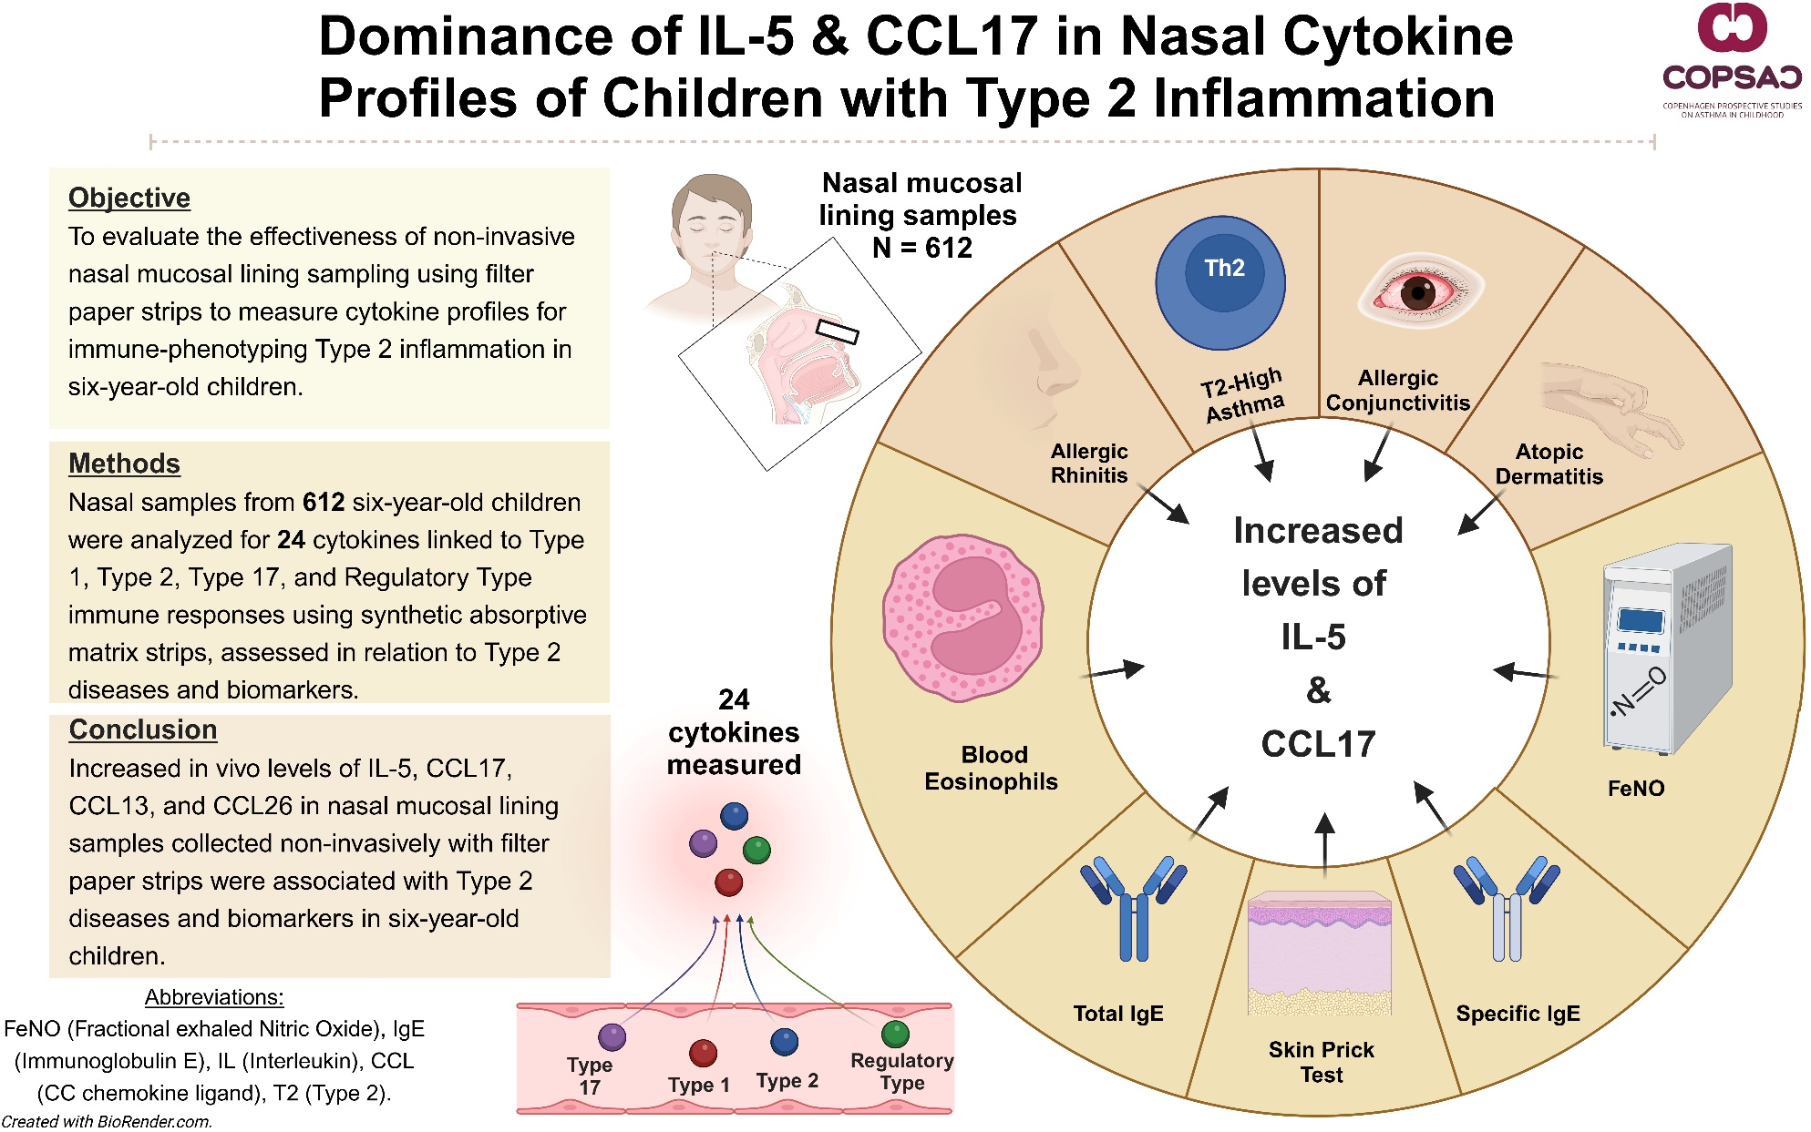

**Graphical Abstract**